Embedded CRAN Analytics

Introduction

The world is moving towards Internet of Things (IoT). It consists of a wide range of use cases, some of which are complicated. Recently, the industry has coined the term Massive IoT, referring to the large number of devices and machines connected over the Internet. IoT applications require high availability, coverage and low latency and this is being done using 5G.

According to a study by McKinsey, IoT has the potential to become a $11 Trillion Industry by 2025. IoT covers various business verticals such as Connected Wearables, Connected Cars, Connected Homes, Connected Cities and Industrial IoT.

Forecasts show that the IoT Market will grow by several orders of magnitude in the next few years. The predicted number of Cellular IoT Devices will be 28× in 2020 compared to the number of 2014. In addition to this, we are seeing a non-linear rise in data traffic over the Internet due to the rise of IoT Devices. According to Ericsson’s Mobility Report, the increase in data traffic will be from approximately 4 EB/month in 2014 to over 40 EB/month in 2020.

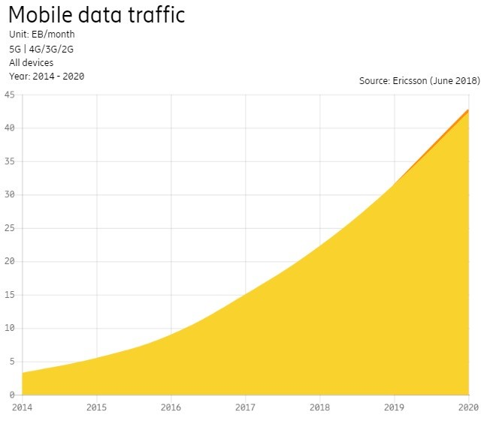

Problem Definition

The LTE Architecture consisted of UE, E-UTRAN, EPC and the Servers. The data from the UE was sent to the BTSs which are under E-UTRAN. The BTSs in E-UTRAN have its own processing which is done at the node itself. The data on the E-UTRAN is sent to the EPC which is connected to the servers, where the processing takes place. With many UEs connected to the BTS, the stress on a single BTS would increase. As we saw earlier, we will have multiple times the devices that we have today within the next few years that will cause a surge in traffic. Adding more stations increases the cost and can lead to signal interference.

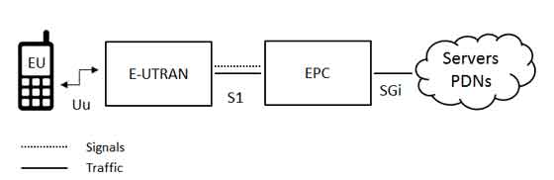

As the amount of traffic on the mobile networks rises, operators are using the Cloud/Centralized Radio Access Network to solve this. Separating the base station into 2 parts, the Baseband Unit (BBU) and the Remote Radio Head (RRH) allows network operators to maintain or increase the number of network access points (RRHs), while centralizing the baseband processing functions into a Master Base Station. Using the Master Base Station simplifies radio resource management in complex operating environments such as Carrier Aggregation. This is seen to be cost efficient and reduces interference. The data from this is sent to the EPC which is connected to the Servers.

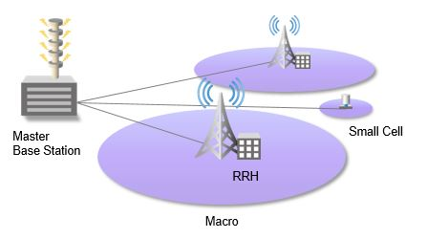

Now, as the number of UEs increases, the data received by all these UEs would increase. While the CRAN is equipped to tackle this data using Master Base Station, it would be difficult for EPC to keep up with this. The computational power of the Servers will not rise proportionately with the rise of data and the UEs. This would create problems with Latency and Interference at the EPC.

Sample Problem

Today, most of the Analytics done on the Network is performed on the Server connected to the EPC. Nokia is using Machine Learning on the EPC. In a MIMO (multiple-input multiple-output) network, cellular base stations send and receive radio frequency signals in parallel through many more antennas than are normally used on a base station. This means the base station can transmit and receive more data, but these signals also interfere with one another.

Beamforming is a signal processing technology that lets base stations send targeted beams of data to users, reducing interference and making more efficient use of the radio-frequency spectrum.

One of the challenges in building these systems is figuring out how to schedule the beams. Nokia, for example, has a system with 128 antennas all working together to form 32 beams and wants to schedule up to four beams in a specified amount of time. The company also wants to schedule those beams in a sequence that will provide the highest spectral efficiency, which is a measure of how many bits per second a base station can send to a set of users.

The number of possible ways to schedule four of 32 beams mathematically adds up to more than 30,000 options. There’s simply not enough processing power on a base station to quickly find the best schedule for that many combinations.

Nokia says it was able to train neural networks how to find the best schedule offline, and then later quickly predict the best schedules on demand, although the company did not provide data to back up their performance or allow comparisons to other possible heuristics.

Solution

As Nokia is using Neural Networks, they do not have enough processing power on the base station to solve this issue in real time. For this, we need low power Machine Learning Algorithms that will work on the base station utilizing its power. Many low power algorithms utilizing the Kernel Trick exist which reduce the computational complexity of the problem and enables us to run Machine Learning on the Edge.

As the Master Base Station utilizes Distributed processing, we can make use of low power algorithms over a distributed network such as Distributed SVM Algorithm developed at the Embedded and Codesign Lab at Texas A&M University. This algorithm would fit on to the Master Base Station and would provide insights on the data received from the RRUs. This would reduce the load on the EPC by solving most of the problems at the Edge itself.